Feasibility Report

Blood Bank

**Problem Statement:**

The problem with the current blood bank system is that while blood can only be stored for a short span of time, the need for blood may arise at any moment ,also the portion of the population who are eligible to donate blood can only do so once every three to four months. The problem is further compounded by the fact that there are several blood types and not all of them are compatible. Hence all these factors add up to make it harder to find the people who can donate blood of the right type within a short distance in a short span of time. Blood banks will have to dispose of the blood that is not used within 42 days, which is a colossal waste.

Blood banks lack transparency which the application would provide.

**Project Business Requirement**:

The problems stated above provide us with a scope for creating an application that would create a dynamic supply of blood so that blood is available as and when it is needed, hence fulfilling the need for supply and thereby avoiding the need for storage and wastage of blood. This can be done by creating a mobile application that can allow a user to create an alert requesting for blood, and allow the donors within a suitable distance to respond.

**Market consideration:**

The following diagram shows the availability of blood and its components at INDIAN RED CROSS SOCIETY-KARNATAKA STATE BRANCH[1].

And as on 12-08-16, 10 AM availability of Single Donor Platelets, AKA whole blood with the IRCS itself was NIL. IRCS Karnataka sector did not possess any blood of any type. This shows the monumental need for the requirement of blood in the state. Hence the scope for such an app as the one proposed is very good.

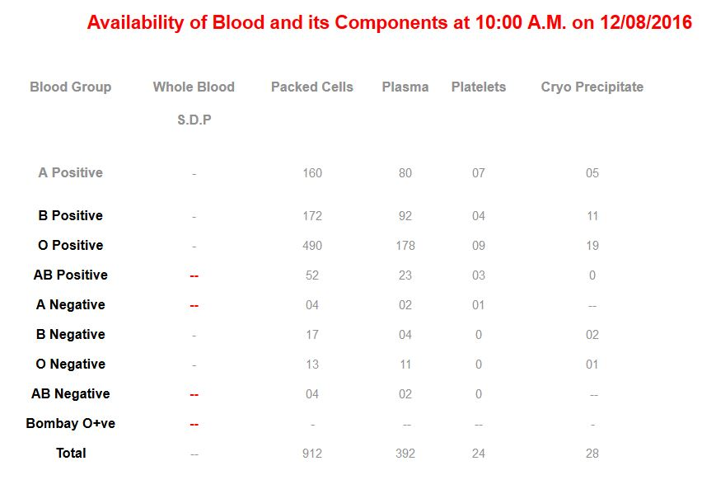

**Marketing plans:**

The product can be marketed at hospitals and at blood banks and to the public in general. The marketing at blood banks themselves would help as the banks often face a shortage of blood at times in need and the people in need would have to find another source immediately ,and generally people who are not familiar with such an application would approach the blood bank first.

**Risk analysis:**

If the density of donors who are using the app is low, the requirement for blood will not be met immediately, and hence the usability of the app will be low. Hence the bigger the user base of the app the more efficient it will be. This would mean that the app would have to be highly scalable as the growth of the app needs to be exponential.

Blood donation is a very stringent process, and the blood donation form alone has around ten fields which need to be filled by the user regarding his or her health condition. We can collect this information by the user in order to vet him for the process but as of now there is no solution which allows us to test the claims made by him, as these claims are medical. Hence the database would contain unverified data.

**Reference:**

1. http://redcrosskarnataka.org/index.php/2015-10-17%2011:43:31_128545/2015-10-17-11-43-49-241489